Estimation Lesson 6 GPS Denied Navigation

[1. Sebastian Introduction](https://classroom.udacity.com/nanodegrees/nd787/parts/a1505b23-c1aa-4bc6-a94c-d44d062d0209/modules/19b5af05-2ec7-491a-94db-1befc15d07c0/lessons/66cf1a91-9b17-4ae8-a5eb-4e8085b8a12c/concepts/e9b8578d-8a17-41c5-a4f8-5daabaf0e6b9)

<https://www.youtube.com/watch?v=tpsrAr13aUo>

[2. Introduction](https://classroom.udacity.com/nanodegrees/nd787/parts/a1505b23-c1aa-4bc6-a94c-d44d062d0209/modules/19b5af05-2ec7-491a-94db-1befc15d07c0/lessons/66cf1a91-9b17-4ae8-a5eb-4e8085b8a12c/concepts/21a6c280-976b-4dfd-871a-0303382ace93)

<https://www.youtube.com/watch?v=he2b-oN5ehs>

[3. Optical Flow Estimation Overview](https://classroom.udacity.com/nanodegrees/nd787/parts/a1505b23-c1aa-4bc6-a94c-d44d062d0209/modules/19b5af05-2ec7-491a-94db-1befc15d07c0/lessons/66cf1a91-9b17-4ae8-a5eb-4e8085b8a12c/concepts/0641445d-3dc0-4368-803f-48bcbbba3ad5)

<https://www.youtube.com/watch?v=Ar4wSP28NtM>

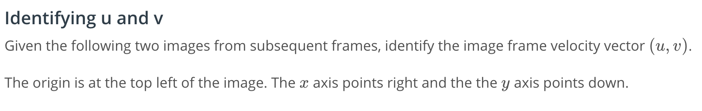

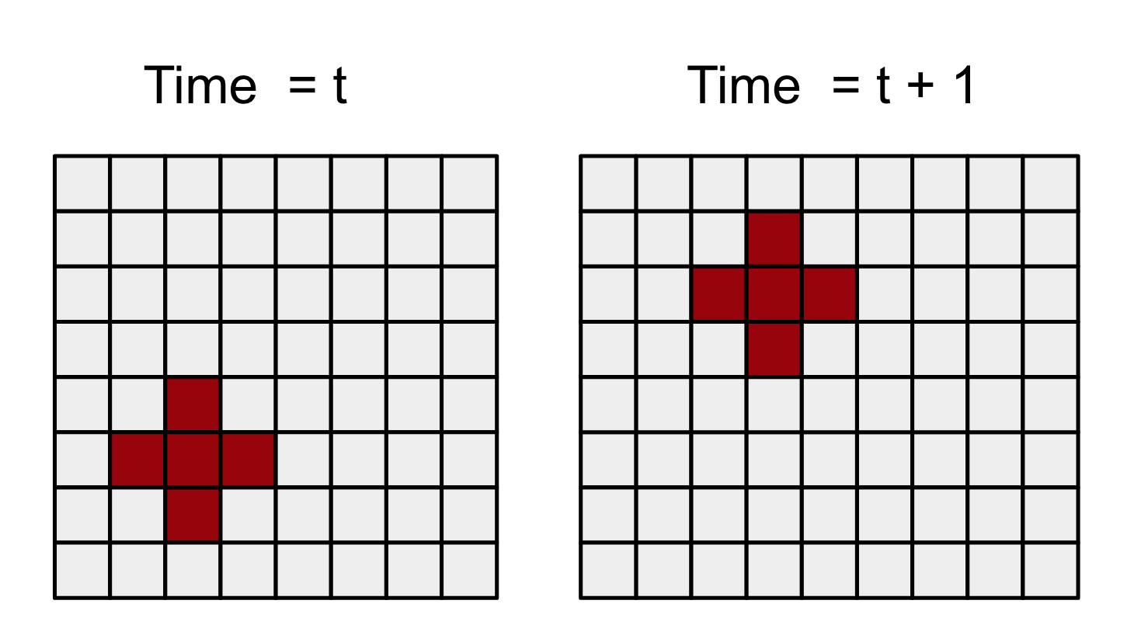

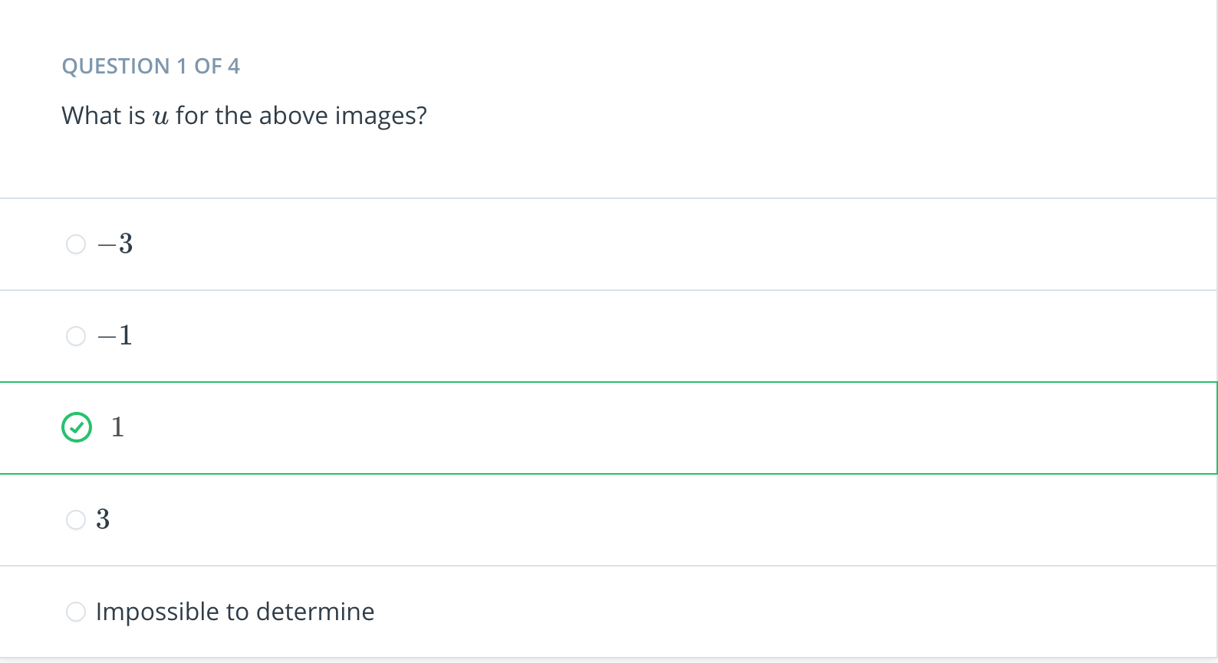

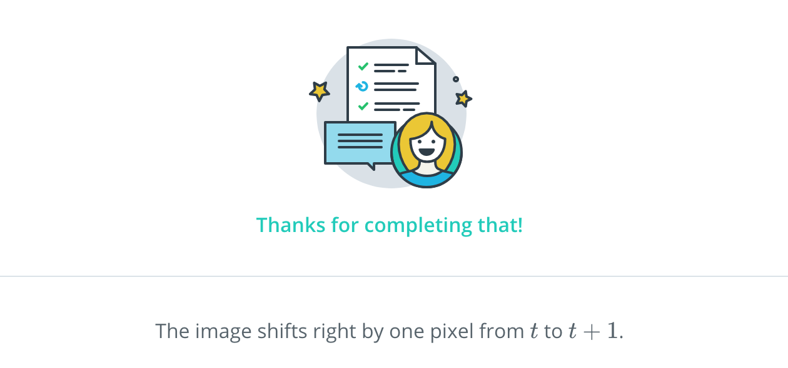

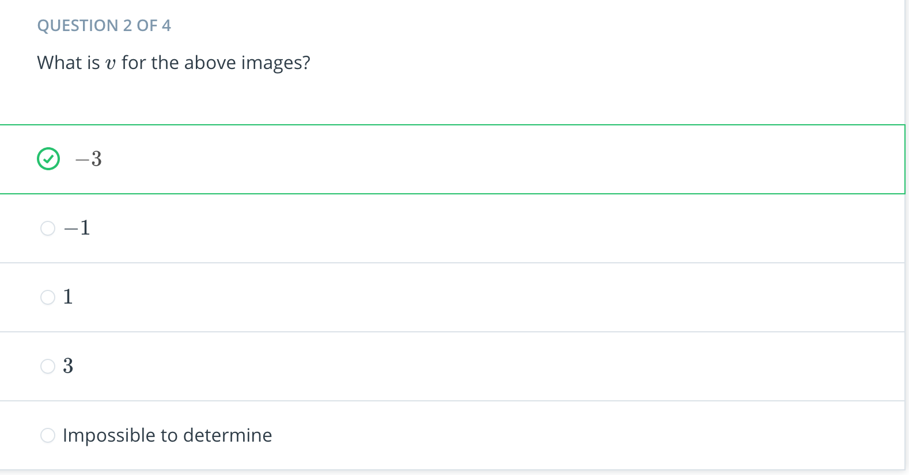

Now, consider the following two images of a long vertical line taken at subsequent frames.

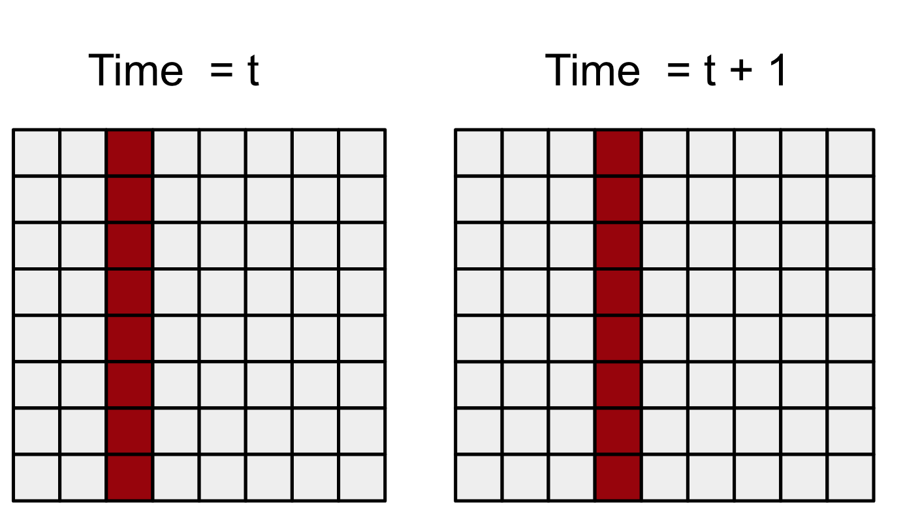

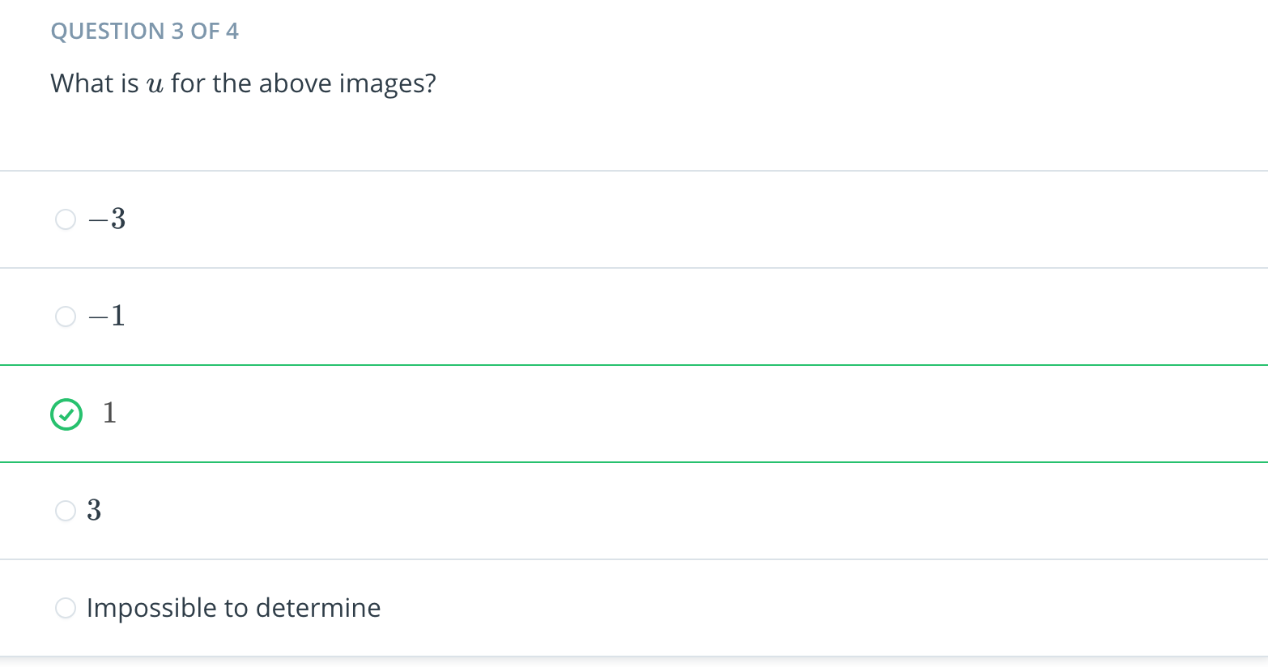

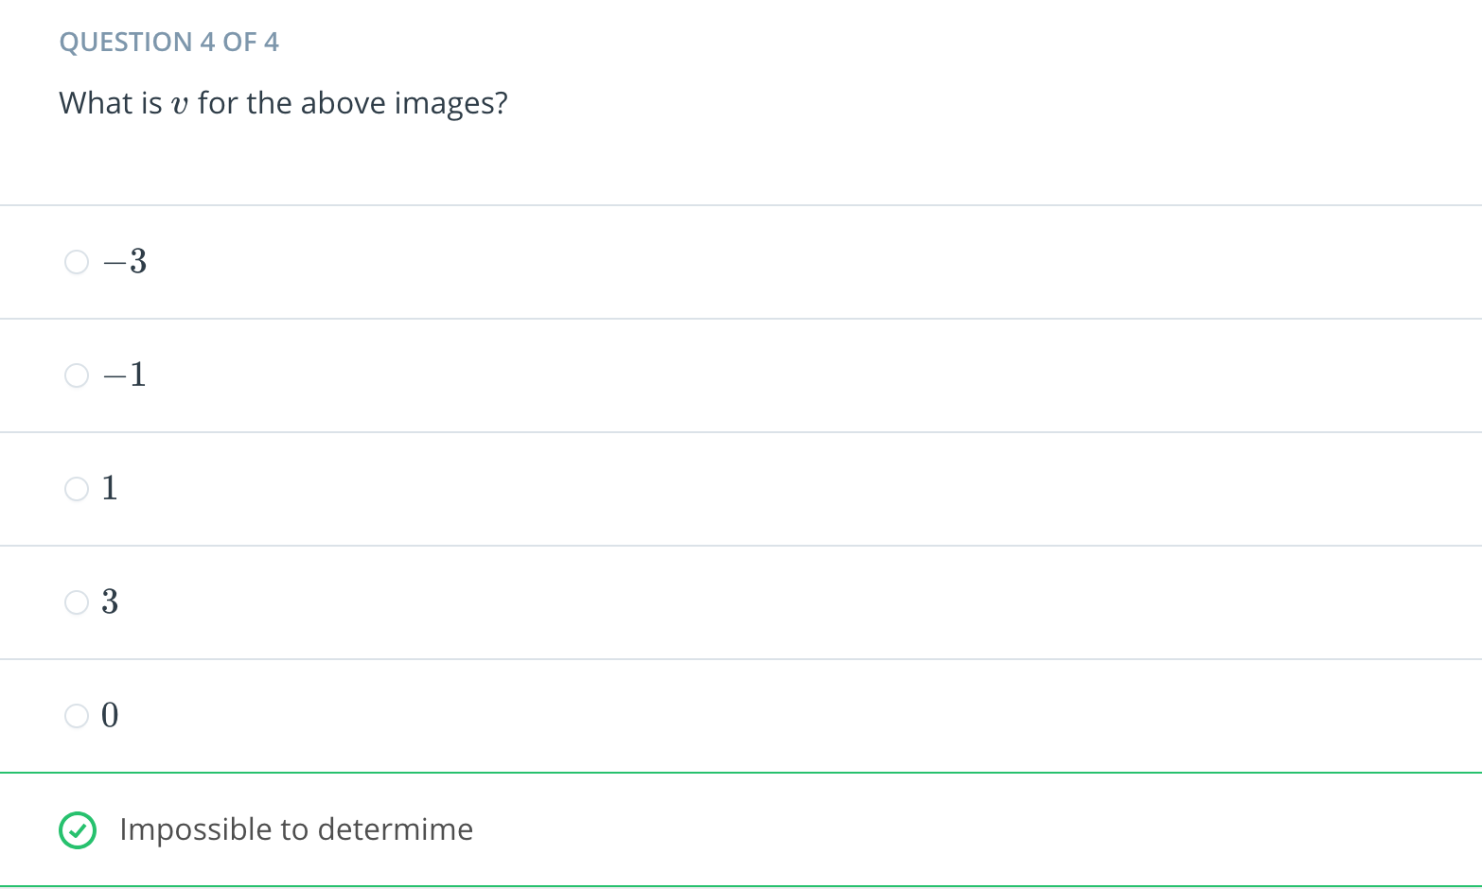

[4. Good Features to Track](https://classroom.udacity.com/nanodegrees/nd787/parts/a1505b23-c1aa-4bc6-a94c-d44d062d0209/modules/19b5af05-2ec7-491a-94db-1befc15d07c0/lessons/66cf1a91-9b17-4ae8-a5eb-4e8085b8a12c/concepts/7bf04f59-4664-4416-ab7e-b0eb0bafeb56)

<https://www.youtube.com/watch?v=Tl51Hmt-MMs>

[5. Feature Tracker Exercise](https://classroom.udacity.com/nanodegrees/nd787/parts/a1505b23-c1aa-4bc6-a94c-d44d062d0209/modules/19b5af05-2ec7-491a-94db-1befc15d07c0/lessons/66cf1a91-9b17-4ae8-a5eb-4e8085b8a12c/concepts/01063c18-6894-4ce6-a9d8-350f3e5679ea)

[Feature-Tracker.ipynb](https://view21636b04.udacity-student-workspaces.com/notebooks/Feature-Tracker.ipynb)

[6. Tracking a Single Pixel](https://classroom.udacity.com/nanodegrees/nd787/parts/a1505b23-c1aa-4bc6-a94c-d44d062d0209/modules/19b5af05-2ec7-491a-94db-1befc15d07c0/lessons/66cf1a91-9b17-4ae8-a5eb-4e8085b8a12c/concepts/4bd4150b-9fad-44d5-8332-072cf8603bea)

<https://www.youtube.com/watch?v=7b-DUiAxuJo>



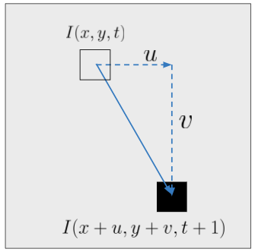

From this picture, it's easy to figure out the velocity vector (*u*,*v*). But when we look at two real images, we'd first need to solve what's called the **pixel correspondence problem**. That is, we need to know which pixels in image 2 correspond to which pixels in image 1.

To solve this problem we make two assumption.

**Assumption 1: the motion is small**: this means we can look in the vicinity of where the pixel *was* to try to determine where it now *is*.

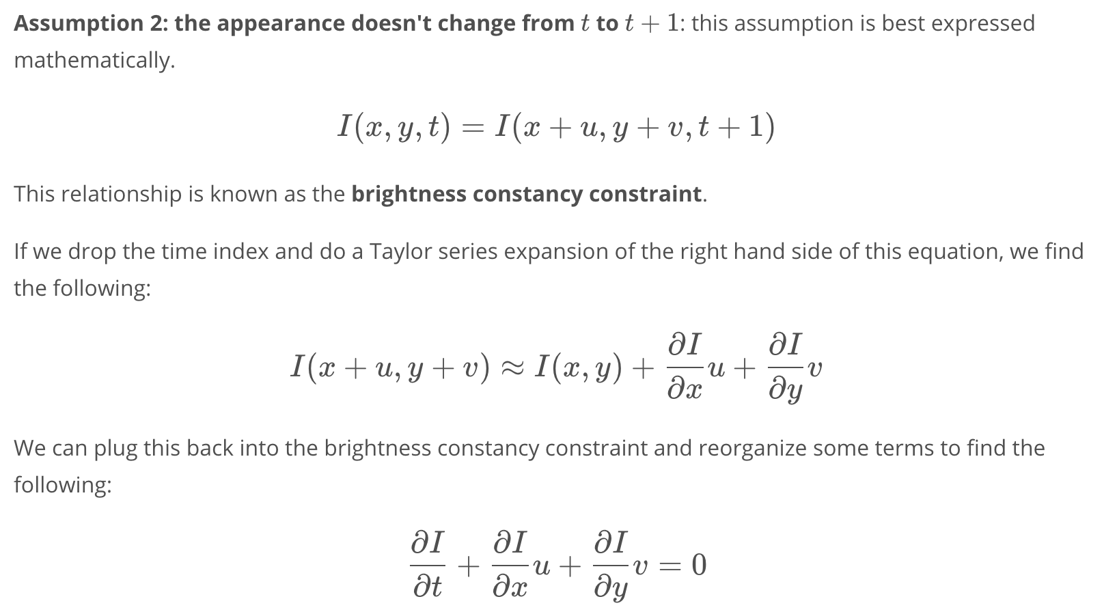

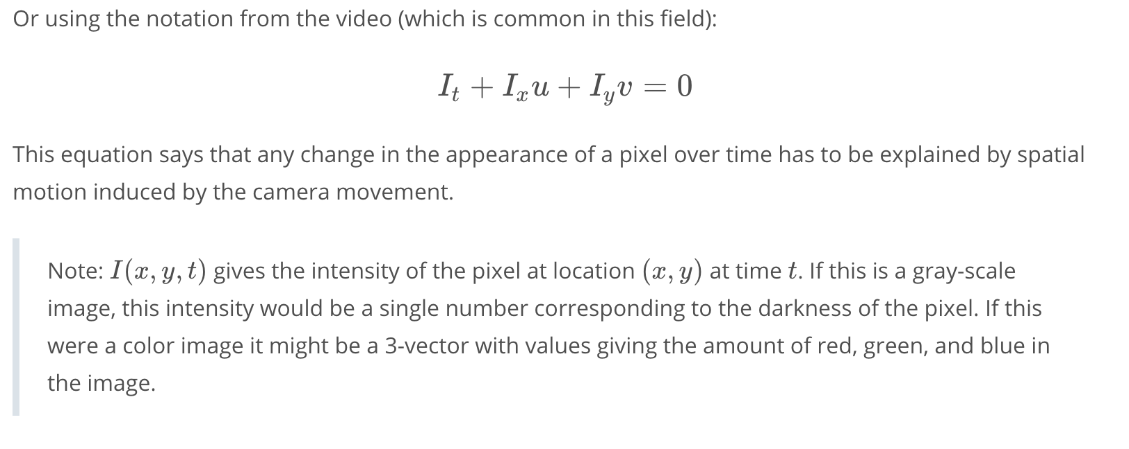

[7. Lucas Kanade Optical Flow](https://classroom.udacity.com/nanodegrees/nd787/parts/a1505b23-c1aa-4bc6-a94c-d44d062d0209/modules/19b5af05-2ec7-491a-94db-1befc15d07c0/lessons/66cf1a91-9b17-4ae8-a5eb-4e8085b8a12c/concepts/8efb2520-9d12-4abe-845a-9b9da73a1ab8)

<https://www.youtube.com/watch?v=oCtNseXe-SE>

[8. Optical Flow Exercise](https://classroom.udacity.com/nanodegrees/nd787/parts/a1505b23-c1aa-4bc6-a94c-d44d062d0209/modules/19b5af05-2ec7-491a-94db-1befc15d07c0/lessons/66cf1a91-9b17-4ae8-a5eb-4e8085b8a12c/concepts/56be7eed-9b15-41f5-b7eb-f3342bc608d1)

[Optical-Flow.ipynb](https://view6a856277.udacity-student-workspaces.com/notebooks/Optical-Flow.ipynb)

[9. Translating Optical Flow to Vehicle Velocity](https://classroom.udacity.com/nanodegrees/nd787/parts/a1505b23-c1aa-4bc6-a94c-d44d062d0209/modules/19b5af05-2ec7-491a-94db-1befc15d07c0/lessons/66cf1a91-9b17-4ae8-a5eb-4e8085b8a12c/concepts/40c47de2-d7ba-446f-bee9-a3cd1ab5e036)

<https://www.youtube.com/watch?v=AYJw2iHnqws>

[10. Intro to Particle Filters](https://classroom.udacity.com/nanodegrees/nd787/parts/a1505b23-c1aa-4bc6-a94c-d44d062d0209/modules/19b5af05-2ec7-491a-94db-1befc15d07c0/lessons/66cf1a91-9b17-4ae8-a5eb-4e8085b8a12c/concepts/3aa6d875-9436-4444-bb3e-40f6fbb07a44)

<https://www.youtube.com/watch?v=ELDLiyGN-7I>

[11. Sampled Distributions](https://classroom.udacity.com/nanodegrees/nd787/parts/a1505b23-c1aa-4bc6-a94c-d44d062d0209/modules/19b5af05-2ec7-491a-94db-1befc15d07c0/lessons/66cf1a91-9b17-4ae8-a5eb-4e8085b8a12c/concepts/17603d31-fe07-45f3-a092-d7eea6b56c6d)

<https://www.youtube.com/watch?v=946LtGH0DCs>

[12. Propagating Samples](https://classroom.udacity.com/nanodegrees/nd787/parts/a1505b23-c1aa-4bc6-a94c-d44d062d0209/modules/19b5af05-2ec7-491a-94db-1befc15d07c0/lessons/66cf1a91-9b17-4ae8-a5eb-4e8085b8a12c/concepts/df98f75e-c2cf-41c6-bc2e-f5b57e8d4da1)

<https://www.youtube.com/watch?time_continue=5&v=i50D7RJqcIk>

[13. Numerical Estimation Exercise](https://classroom.udacity.com/nanodegrees/nd787/parts/a1505b23-c1aa-4bc6-a94c-d44d062d0209/modules/19b5af05-2ec7-491a-94db-1befc15d07c0/lessons/66cf1a91-9b17-4ae8-a5eb-4e8085b8a12c/concepts/7e597350-d94b-40d9-81e7-b8446084b0ec)

[Numerical-Estimation.ipynb](https://viewd8eaef9c.udacity-student-workspaces.com/notebooks/Numerical-Estimation.ipynb)

[14. Sampling from Arbitrary Distributions](https://classroom.udacity.com/nanodegrees/nd787/parts/a1505b23-c1aa-4bc6-a94c-d44d062d0209/modules/19b5af05-2ec7-491a-94db-1befc15d07c0/lessons/66cf1a91-9b17-4ae8-a5eb-4e8085b8a12c/concepts/ae4471b9-1705-44db-98f8-28623adc7517)

<https://www.youtube.com/watch?v=Qwzd-9SmSxc>

[15. Sensor Modeling](https://classroom.udacity.com/nanodegrees/nd787/parts/a1505b23-c1aa-4bc6-a94c-d44d062d0209/modules/19b5af05-2ec7-491a-94db-1befc15d07c0/lessons/66cf1a91-9b17-4ae8-a5eb-4e8085b8a12c/concepts/59253b57-2855-4e91-a140-ad6683874bba)

<https://www.youtube.com/watch?v=5MPNYyKvHbc>

[16. Monte Carlo Sampling for Sensor Fusion](https://classroom.udacity.com/nanodegrees/nd787/parts/a1505b23-c1aa-4bc6-a94c-d44d062d0209/modules/19b5af05-2ec7-491a-94db-1befc15d07c0/lessons/66cf1a91-9b17-4ae8-a5eb-4e8085b8a12c/concepts/4d81af4c-98ed-4f98-bb05-bcf89dd21814)

<https://www.youtube.com/watch?time_continue=3&v=K2bd8zcoicU>

[17. Sensor Fusion Exercise](https://classroom.udacity.com/nanodegrees/nd787/parts/a1505b23-c1aa-4bc6-a94c-d44d062d0209/modules/19b5af05-2ec7-491a-94db-1befc15d07c0/lessons/66cf1a91-9b17-4ae8-a5eb-4e8085b8a12c/concepts/0c7255cb-1740-414e-b79e-7bfb5d460b02)

[Sensor-Fusion.ipynb](https://view60d5d90c.udacity-student-workspaces.com/notebooks/Sensor-Fusion.ipynb)

[18. Putting it All Together](https://classroom.udacity.com/nanodegrees/nd787/parts/a1505b23-c1aa-4bc6-a94c-d44d062d0209/modules/19b5af05-2ec7-491a-94db-1befc15d07c0/lessons/66cf1a91-9b17-4ae8-a5eb-4e8085b8a12c/concepts/44ff3952-8df5-4f1b-8a4c-3ab349a31230)

<https://www.youtube.com/watch?v=sKL8dIoJvW0>

[19. Particle Filter Exercise](https://classroom.udacity.com/nanodegrees/nd787/parts/a1505b23-c1aa-4bc6-a94c-d44d062d0209/modules/19b5af05-2ec7-491a-94db-1befc15d07c0/lessons/66cf1a91-9b17-4ae8-a5eb-4e8085b8a12c/concepts/ffd70c18-2429-447a-8b54-919e0fa3692a)

[Particle-Filter.ipynb](https://view76d5583d.udacity-student-workspaces.com/notebooks/Particle-Filter.ipynb)

[20. Particle Filter Pros and Cons](https://classroom.udacity.com/nanodegrees/nd787/parts/a1505b23-c1aa-4bc6-a94c-d44d062d0209/modules/19b5af05-2ec7-491a-94db-1befc15d07c0/lessons/66cf1a91-9b17-4ae8-a5eb-4e8085b8a12c/concepts/6131dc1a-cd32-4b94-99b4-480e695f2dad)

<https://www.youtube.com/watch?v=ghaL55MOZHI>

[21. Conclusion](https://classroom.udacity.com/nanodegrees/nd787/parts/a1505b23-c1aa-4bc6-a94c-d44d062d0209/modules/19b5af05-2ec7-491a-94db-1befc15d07c0/lessons/66cf1a91-9b17-4ae8-a5eb-4e8085b8a12c/concepts/5f1e93f5-fab1-402d-ba84-f27d5ee94cc6)

<https://www.youtube.com/watch?v=zcAOzXxidug>

## **Additional Resources**

* This [Github repository](https://github.com/rlabbe/Kalman-and-Bayesian-Filters-in-Python) is a sequence of interactive Jupyter notebooks on Kalman Filters, Particle Filters, etc... we highly recommend you take a look if you're looking to learn more about Particle Filters.
* Udacity has a free course called [Artificial Intelligence for Robotics](https://classroom.udacity.com/courses/cs373). The lesson on particle filters takes a more simplified approach to the topic.